User Story 3
As a developer, I want the AI’s repo summaries to include direct code files or line citations so that I can better check explanations and quickly verify them in context.

Development Specification 3:
Chat Log Links: P2-resubmission-chat-histories
https://chatgpt.com/g/g-p-68d9bf2c81588191a1e8e3abf389cc83-ai-tool/c/6907839c-5e4c-832e-aed2-0fc5e1a26a71

1. Header
Version: v2.0 (2025-10-27)
Authors:
- Christina Ma
- Baolin Shi
- Dejun Yang

2. Architecture Diagram
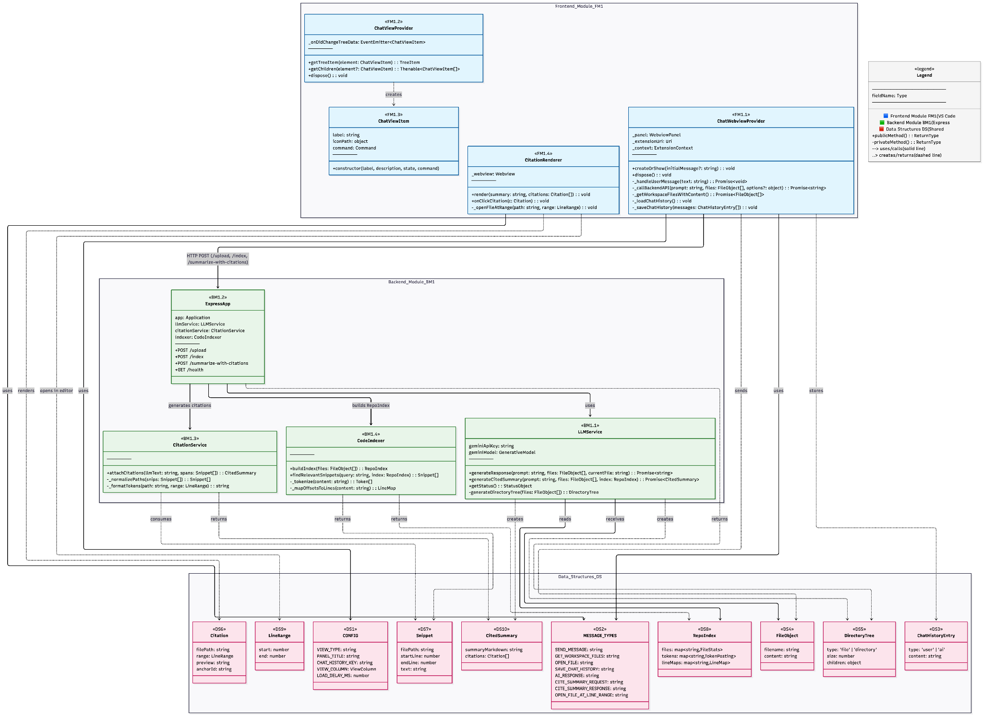
Rationale: We extended the US1 architecture with minimal additions to support clickable file and line citations in AI summaries. The same frontend–backend–data separation is preserved: the CodeIndexer builds a repo index for precise line mapping, the CitationService attaches citations to LLM outputs, and the CitationRenderer displays them in VS Code. New data structures formalize citation objects for consistent exchange. This design keeps responsibilities clear, performance predictable, and the overall structure aligned with US1.

3. Class Diagram
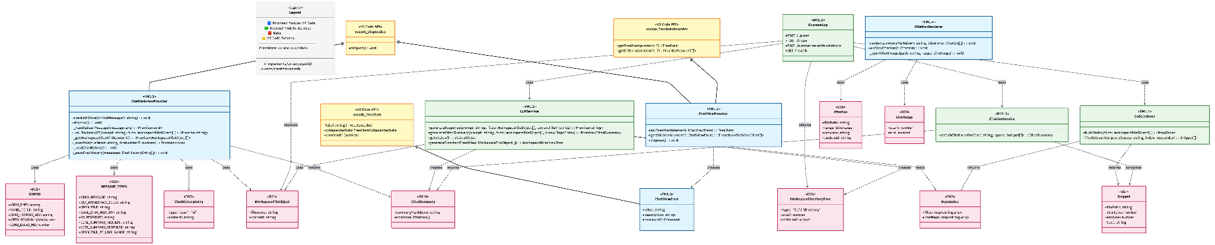
Rationale: The class diagram extends US1 by adding minimal new classes to support file and line-level citations in AI summaries. It shows how user input from ChatWebviewProvider still flows through ExpressApp and LLMService, but now includes CodeIndexer and CitationService to generate and attach citation data. On the frontend, CitationRenderer visualizes clickable citations linked to files and line ranges.

4. List of Classes

Frontend Module (FM1)
FM1.1 ChatWebviewProvider
Location: frontend/ai-chatbot-extension/src/chatWebviewProvider.ts
Purpose: Manages the webview panel, chat history, workspace file collection, backend calls, and file navigation. For US3, it parses AI markdown to detect [label](path:line) patterns and renders per-line citation buttons; clicking opens the file at the target line.
Implements: US1 (Repo Awareness) + US3 (Clickable file/line citations)
Type: VS Code Extension Class (TypeScript)
FM1.2 ChatViewProvider
Location: frontend/ai-chatbot-extension/src/chatViewProvider.ts
Purpose: Sidebar tree view integration for quick access to the chat interface.
Implements: US1/2/3 – entry to chat UI
Type: VS Code Tree Data Provider Class (TypeScript)
FM1.3 ChatViewItem
Location: frontend/ai-chatbot-extension/src/chatViewProvider.ts (lines ~61–76)
Purpose: Tree items used by the sidebar; wires commands to open the chat.
Implements: US1/2/3 – access point to chat UI
Type: VS Code Tree Item Class (TypeScript)

Backend Module (BM1)
BM1.1 LLMService
Location: backend/services/llmService.js
Purpose: Generates AI responses (Gemini or mock), prepares file context, builds directory tree, and (for US3) prompts the model to produce markdown links in the format [label](relative/path:line) so the frontend can parse and jump to exact lines.
Implements: US1/2/3 – repo summaries with file/line references in text
Type: Service Class (JavaScript)
BM1.2 ExpressApp
Location: backend/index.js
Purpose: HTTP server exposing /upload (files + prompt) and /health. Returns AI text plus a directory tree; no extra endpoints are added for US3.
Implements: US1/2/3 – transports entire repo and delivers responses with references
Type: Express Application Instance (JavaScript)

Data Structures
DS1 CONFIG
Location: frontend/ai-chatbot-extension/src/chatWebviewProvider.ts (lines ~11–20)
Purpose: View type, panel title, column, delays.
Type: Configuration Object (TypeScript const)
DS2 MESSAGE_TYPES
Location: frontend/ai-chatbot-extension/src/chatWebviewProvider.ts (lines ~25–37)
Purpose: Webview ↔ extension message kinds (send message, file ops, chat history).
Type: Message Type Constants (TypeScript const)
DS3 Chat History Entry
Location: frontend/ai-chatbot-extension/src/chatWebviewProvider.ts (used in _loadChatHistory/_saveChatHistory, e.g., ~714–716, ~1250+)
Purpose: { type: 'user' | 'ai', content: string } entries persisted under ai-chatbot.chatHistory.
Type: Chat Message Array (TypeScript interface)
DS4 Workspace File Object
Location: frontend/ai-chatbot-extension/src/chatWebviewProvider.ts (return type of _getWorkspaceFilesWithContent, ~line 238); backend/index.js (request body files[])
Purpose: { filename: string, content: string } used end-to-end for context and processing.
Type: File Payload Structure (TS/JS object)
DS5 Workspace Directory Tree
Location: backend/services/llmService.js (generateDirectoryTree, ~lines 135–176)
Purpose: Recursive { type: 'file'|'directory', ... } with size/preview/fullContent for files and children for directories; included in /upload response for context.
Type: Tree Data Structure (JavaScript object)
DS6 Line Citation Reference (US3)
Location: frontend/ai-chatbot-extension/src/chatWebviewProvider.ts (parsing/rendering around ~1117–1184; citation buttons ~1177–1181)
Purpose: Parsed citation object from AI text, e.g., { fileName: string, lineNumber: number }, used to render buttons and open files at the precise line.
Type: Parsed Object (webview script)
DS7 Parsed Line (US3)
Location: frontend/ai-chatbot-extension/src/chatWebviewProvider.ts (parseContentWithCitations, ~line 1117)
Purpose: Holds a rendered line’s text plus an array of Line Citation Reference objects for that line, enabling mixed content + multiple citations.
Type: Internal Render Model (webview script)

5. State Diagram
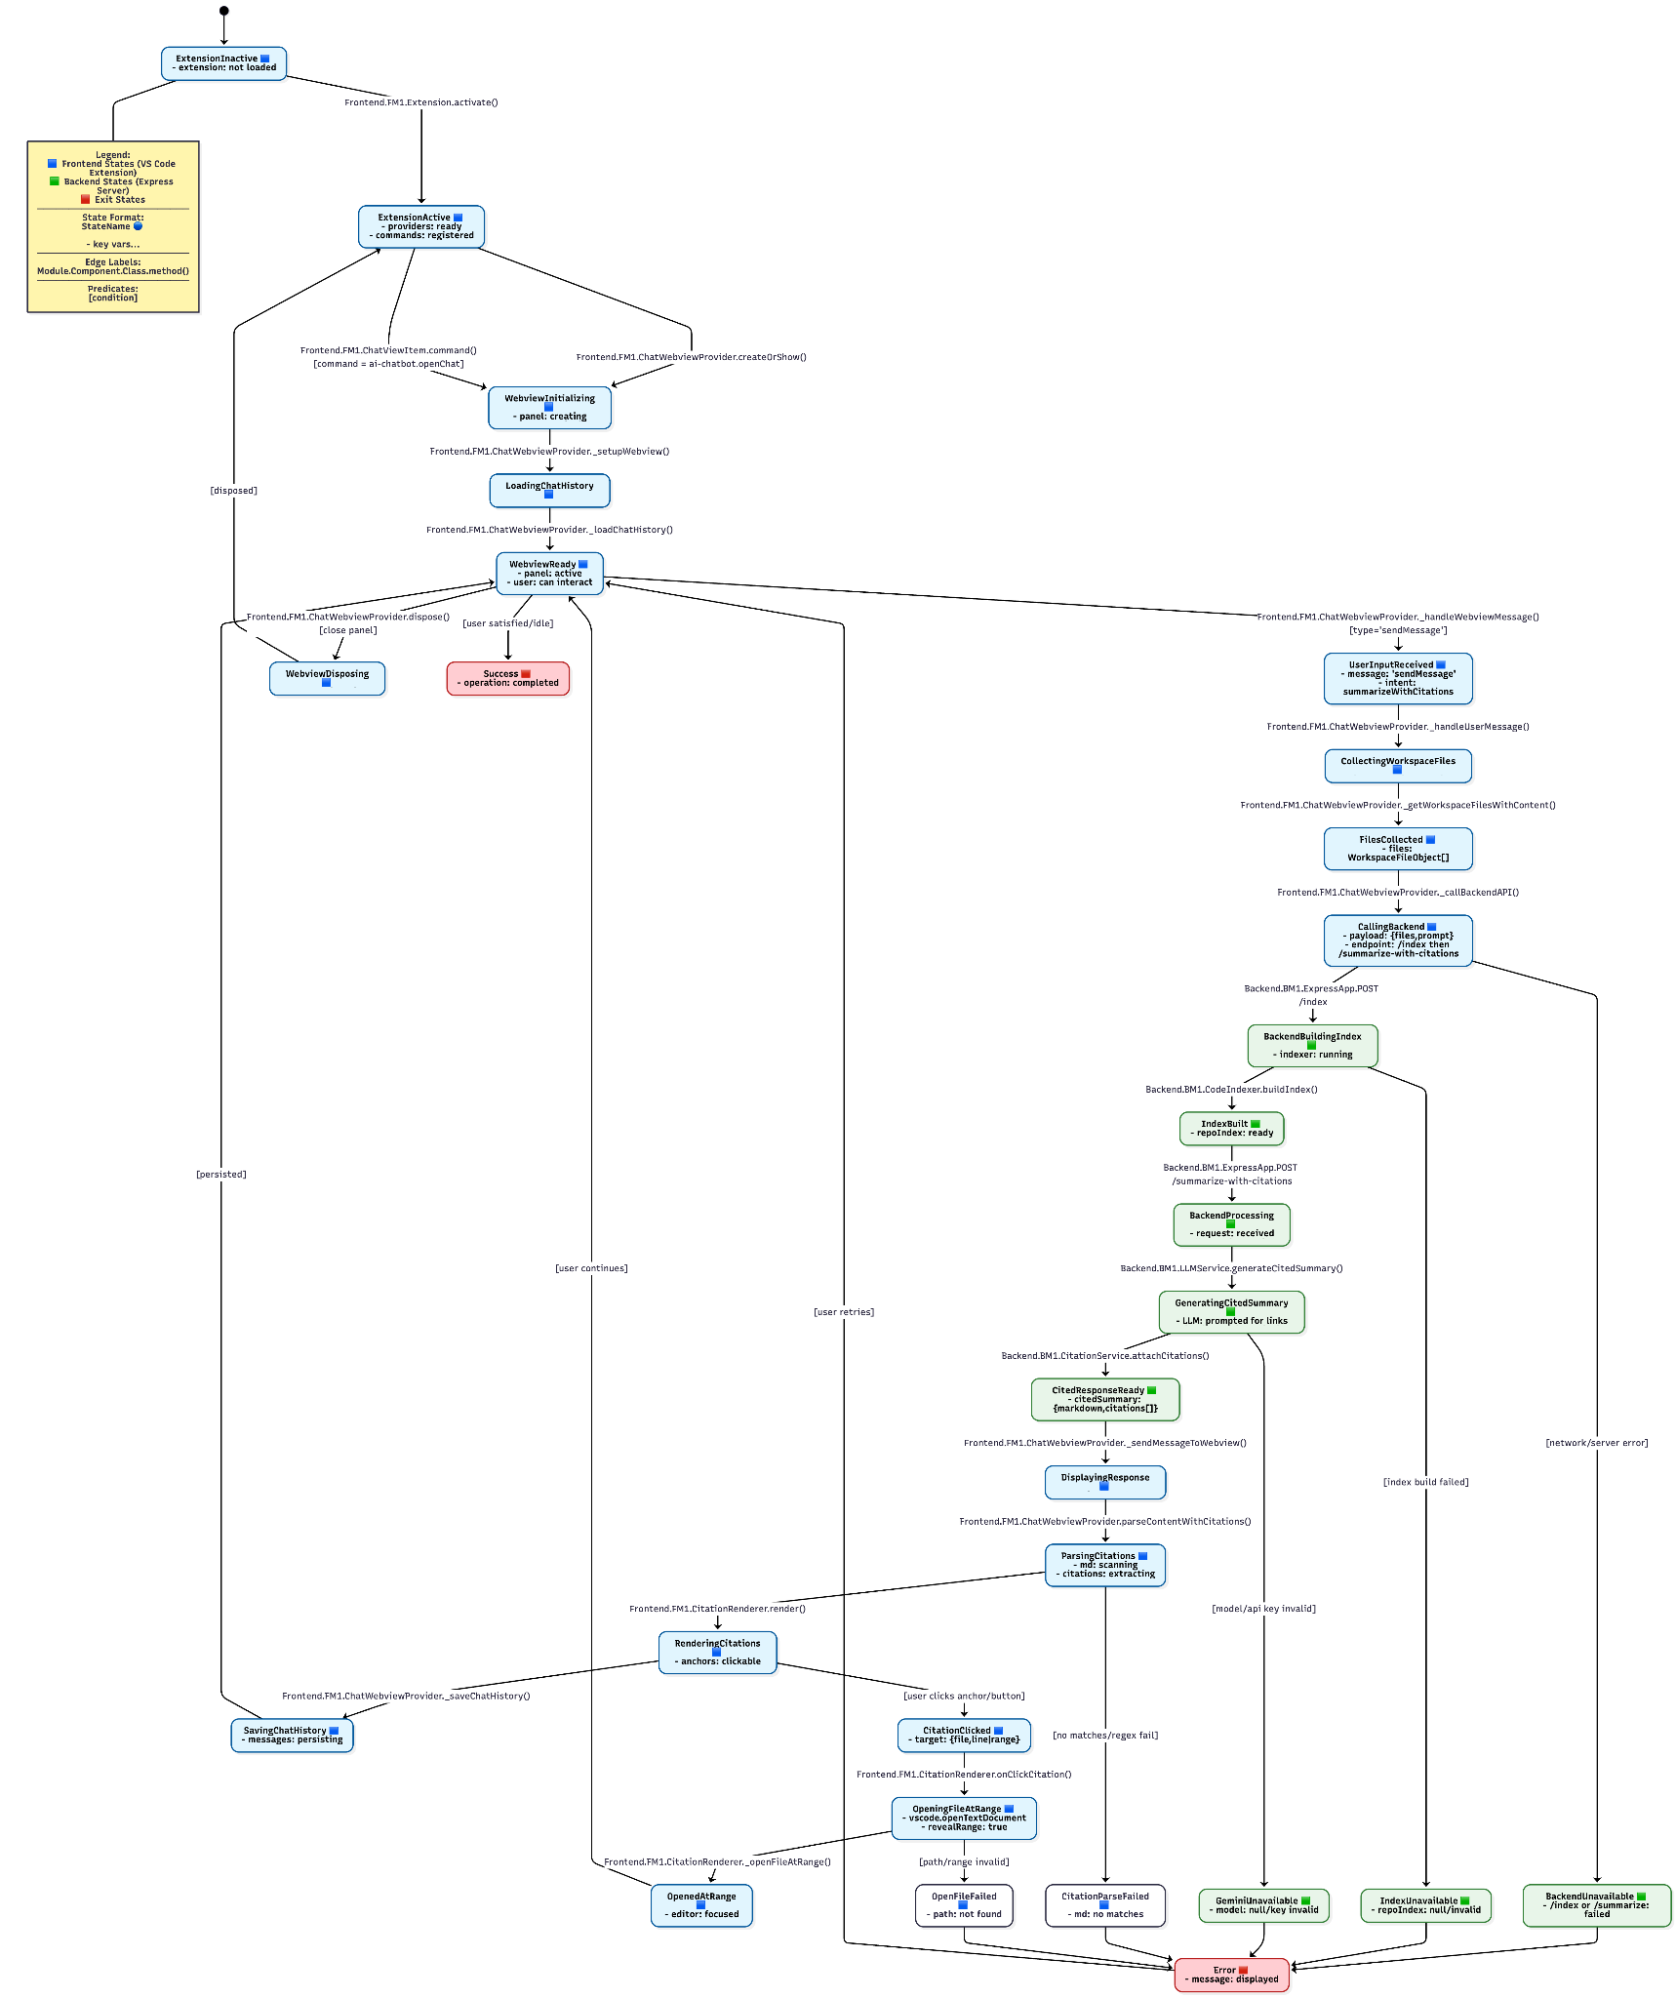
Rationale: This state diagram extends US1 by adding states for citation generation and navigation, including index building, cited summary creation, and file opening at specific lines. It highlights how citation handling integrates into the existing request flow while preserving US1’s overall structure and transitions.

6. Flow Chart
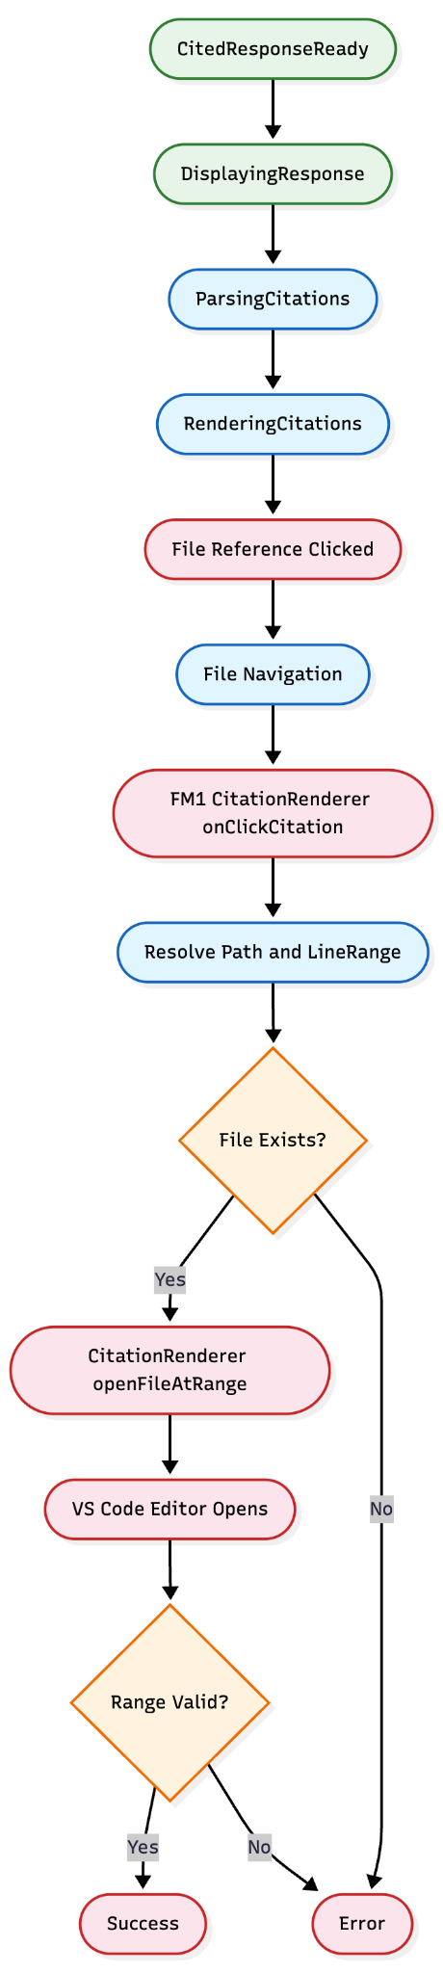
Rationale: This flowchart focuses only on the new citation-handling process introduced in User Story 3. Steps identical to User Story 1are omitted for clarity. The legend, color scheme, and shapes follow the same conventions as in US1 to ensure visual and structural consistency.

7. Development Risks and Failures
System Components Overview
- Frontend: VSCode Extension (TypeScript)
- Backend: Node.js Express Server (JavaScript)
- AI Service: Google Gemini API Integration
- Communication: HTTP/HTTPS API calls
- Storage: Local VSCode extension storage
- New Components (US3): CitationRenderer (frontend), CodeIndexer & CitationService (backend)
Runtime failures
F22: Citation Parsing Failure
Likelihood: Medium | Impact: Low
User-visible effects: AI response shown without clickable file references
Internal effects: Markdown parser fails to extract citation patterns
Recovery procedure:
- Skip citation rendering and show plain AI text
- Log parsing errors for debugging
- Retry parsing on user refresh
F23: File Navigation Failure
Likelihood: Medium | Impact: Medium
User-visible effects: Clicking citation does nothing or opens wrong file/line
Internal effects: _openFileAtRange() fails due to invalid path or range mapping
Recovery procedure:
- Validate file existence and line range before navigation
- Fallback to opening file root
- Display warning to user
F24: Code Index Build Failure
Likelihood: Low | Impact: Medium
User-visible effects: Summaries generated without citations or incomplete links
Internal effects: CodeIndexer.buildIndex() fails to tokenize files or exceeds memory limits
Recovery procedure:
- Retry index build for smaller subsets of files
- Log error and proceed with citation-free summary
- Optimize indexing for large repositories
F25: Citation Alignment Failure
Likelihood: Low | Impact: Medium
User-visible effects: Incorrect line numbers or mismatched file links in summary
Internal effects: CitationService.attachCitations() fails to match snippets to model output
Recovery procedure:
- Fallback to approximate matches using filename only
- Provide warning in developer console
- Improve alignment heuristics in next build
F26: Citation Rendering Error
Likelihood: Low | Impact: Low
User-visible effects: Citation buttons not displayed or styled incorrectly
Internal effects: Rendering pipeline in CitationRenderer.render() throws HTML injection or DOM errors
Recovery procedure:
- Catch and suppress rendering errors
- Display plain text fallback
- Fix DOM injection logic in next update

Connectivity and Data Failures
F27: Citation Payload Desynchronization
Likelihood: Low | Impact: Medium
User-visible effects: Citations point to outdated or changed file content
Internal effects: Repo index not rebuilt after workspace updates
Recovery procedure:
- Auto-rebuild index on file modification event
- Clear old citations and prompt user to refresh summary
- Validate timestamp before rendering

Rationale: The failures and risks listed above focus on new behaviors introduced by User Story 3, such as citation parsing, file navigation, and index-based alignment. All generic extension, backend, API, and network risks remain the same as in User Story 1 and are not repeated here to avoid redundancy. The same mitigation strategies (logging, retries, graceful fallback, and user notifications) continue to apply.

8. Technology Stack
(Same as US1)
Total Technologies: 16
- Backend Technologies: 8 (T1-T8)
- Frontend Technologies: 8 (T9-T16)
- Production Dependencies: 8 (T1-T5, T9-T11)
- Development Dependencies: 8 (T6, T12-T15, T7-T8, T16)
Architecture: VS Code Extension with separate backend API server Language: TypeScript (frontend) + JavaScript (backend) Runtime: Node.js v16+ AI Integration: Google Gemini via official SDK
Backend Technologies
T1: Node.js (v16.x or higher)
- Purpose: JavaScript runtime environment for backend server
- Why chosen: Industry standard for JavaScript server applications, excellent npm ecosystem
- Source: https://nodejs.org/
- Documentation: https://nodejs.org/docs/
- Version: >=16.0.0 (as specified in package.json engines)
T2: Express.js (v4.18.2)
- Purpose: Web framework for handling HTTP requests and routing
- Why chosen: Most popular Node.js web framework, simple and flexible
- Source: https://www.npmjs.com/package/express
- Documentation: https://expressjs.com/
- Version: ^4.18.2
T3: Google Generative AI SDK (@google/generative-ai v0.24.1)
- Purpose: Integration with Gemini AI for generating summaries and citations
- Why chosen: Official Google SDK for Gemini, provides type-safe API access
- Source: https://www.npmjs.com/package/@google/generative-ai
- Documentation: https://ai.google.dev/docs
- Version: ^0.24.1
T4: CORS (v2.8.5)
- Purpose: Enable Cross-Origin Resource Sharing for frontend-backend communication
- Why chosen: Essential for allowing frontend applications to communicate with backend API, standard middleware for Express
- Source: https://www.npmjs.com/package/cors
- Documentation: https://github.com/expressjs/cors
- Version: ^2.8.5
T5: dotenv (v16.3.1)
- Purpose: Load environment variables from .env file
- Why chosen: Standard tool for managing configuration and API keys securely
- Source: https://www.npmjs.com/package/dotenv
- Documentation: https://github.com/motdotla/dotenv
- Version: ^16.3.1
T6: Nodemon (v3.0.1) - Dev Dependency
- Purpose: Auto-restart server on file changes during development
- Why chosen: Improves developer experience by eliminating manual server restarts
- Source: https://www.npmjs.com/package/nodemon
- Documentation: https://nodemon.io/
- Version: ^3.0.1
T7: Built-in Node.js Modules
- Purpose: Core Node.js functionality (http, https, url, fs, path, assert)
- Why chosen: Part of Node.js runtime, no additional dependencies needed
- Source: https://nodejs.org/api/
- Documentation: https://nodejs.org/api/
- Version: Included with Node.js v16+
T8: Bash Shell Scripting
- Purpose: Deployment automation (deploy.sh)
- Why chosen: Standard Unix/Linux scripting for deployment tasks
- Source: Built into Unix/Linux systems
- Documentation: https://www.gnu.org/software/bash/manual/
- Version: System dependent
Frontend Technologies (VS Code Extension)
T9: VS Code Extension API (@types/vscode v1.82.0)
- Purpose: Core API for VS Code extension development
- Why chosen: Required for building VS Code extensions, provides type definitions
- Source: https://www.npmjs.com/package/@types/vscode
- Documentation: https://code.visualstudio.com/api
- Version: ^1.82.0
T10: TypeScript (v4.9.4)
- Purpose: Type-safe JavaScript development for VS Code extension
- Why chosen: Catches errors at compile time, improves code maintainability
- Source: https://www.npmjs.com/package/typescript
- Documentation: https://www.typescriptlang.org/
- Version: ^4.9.4
T11: Axios (v1.6.0)
- Purpose: HTTP client for making API requests from frontend to backend
- Why chosen: Promise-based HTTP client, better than fetch for complex requests
- Source: https://www.npmjs.com/package/axios
- Documentation: https://axios-http.com/docs/intro
- Version: ^1.6.0
T12: ESLint (v8.28.0) - Dev Dependency
- Purpose: JavaScript/TypeScript linting tool
- Why chosen: Industry standard for code quality and consistency
- Source: https://www.npmjs.com/package/eslint
- Documentation: https://eslint.org/docs/latest/
- Version: ^8.28.0
T13: TypeScript ESLint Parser (@typescript-eslint/parser v5.45.0) - Dev Dependency
- Purpose: ESLint parser for TypeScript files
- Why chosen: Required for ESLint to parse TypeScript syntax
- Source: https://www.npmjs.com/package/@typescript-eslint/parser
- Documentation: https://typescript-eslint.io/
- Version: ^5.45.0
T14: TypeScript ESLint Plugin (@typescript-eslint/eslint-plugin v5.45.0) - Dev Dependency
- Purpose: ESLint rules for TypeScript
- Why chosen: Provides TypeScript-specific linting rules
- Source: https://www.npmjs.com/package/@typescript-eslint/eslint-plugin
- Documentation: https://typescript-eslint.io/
- Version: ^5.45.0
T15: @types/node (v16.x) - Dev Dependency
- Purpose: TypeScript type definitions for Node.js
- Why chosen: Provides type safety for Node.js APIs
- Source: https://www.npmjs.com/package/@types/node
- Documentation: https://github.com/DefinitelyTyped/DefinitelyTyped
- Version: 16.x
T16: Built-in Node.js Modules (Frontend)
- Purpose: Core Node.js functionality (path, fs, https, http, url)
- Why chosen: Part of Node.js runtime, no additional dependencies needed
- Source: https://nodejs.org/api/
- Documentation: https://nodejs.org/api/
- Version: Included with Node.js v16+

9. APIs (US3 – Additions Only)
BM1.1 – LLMService (AI Response Generation Service)
New Public Method
BM1.1.9 generateCitedSummary(prompt, files)
- Parameters:
  - prompt: string
  - files: FileObject[]
- Returns: Promise<CitedSummary>
- Purpose: Produces AI summary plus structured citations ({ summaryMarkdown, citations[] }).
- Used by: BM1.2 POST /upload (same endpoint as US1, response now includes citations).
New/Refined Private Helpers (if separated for clarity)
- BM1.1.p1 _prepareCitationPrompt(prompt, files): string – Formats prompt to elicit file/line refs.
- BM1.1.p2 _postprocessMarkdown(md): string – Light cleanup of markdown prior to citation attachment.
BM1.3 – CitationService (Citation Alignment)
BM1.3.1 attachCitations(llmText, index): CitedSummary
- Parameters:
  - llmText: string – Raw LLM output
  - index: RepoIndex – From CodeIndexer
- Returns: CitedSummary – { summaryMarkdown: string, citations: Citation[] }
- Purpose: Aligns LLM spans to {filePath, startLine, endLine} and packs structured citations.
BM1.4 – CodeIndexer (Repo Index)
BM1.4.1 buildIndex(files): RepoIndex
- Parameters: files: FileObject[]
- Returns: RepoIndex
- Purpose: Builds lightweight line maps for precise file/line lookups.
BM1.4.2 findRelevantSnippets(query, index): Snippet[]
- Parameters: query: string, index: RepoIndex
- Returns: Snippet[]
- Purpose: Optional helper for better alignment/spot-checks.
BM1.2 – ExpressApp (HTTP Server)
BM1.2.1 POST /upload (unchanged endpoint; enriched response)
- Request Body: { files: FileObject[], prompt: string }
- Response (US3 superset of US1):
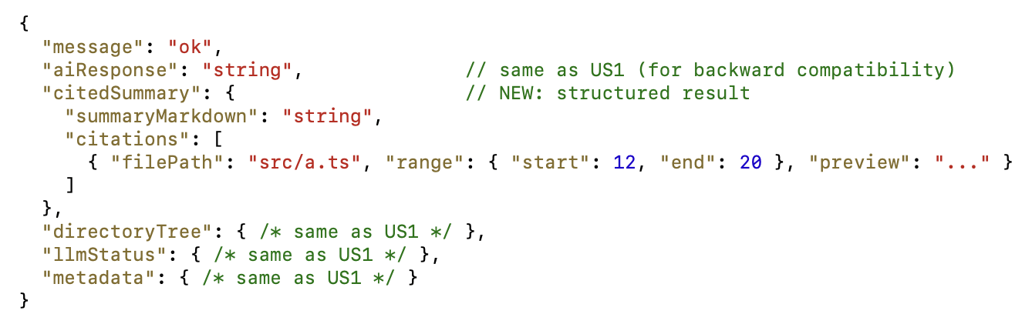
- Purpose change: After US3, /upload invokes CodeIndexer.buildIndex() and LLMService.generateCitedSummary() to attach citations.
- Used by: FM1.1 ChatWebviewProvider._callBackendAPI

10. Public Interfaces (US3 – Additions Only)
Within Backend Module (BM1)
- BM1.2 uses BM1.1:
  - POST /upload → LLMService.generateCitedSummary() (NEW)
  - POST /upload → LLMService.generateDirectoryTree() (same as US1)
- BM1.2 uses BM1.3:
  - POST /upload → CitationService.attachCitations() (NEW)
- BM1.2 uses BM1.4:
  - POST /upload → CodeIndexer.buildIndex() (NEW)
Cross-Module (Frontend → Backend)
- FM1.1 uses BM1.2:
  - _callBackendAPI() → HTTP POST /upload (same)
  - Receives (extended): citedSummary.summaryMarkdown, citedSummary.citations[] (NEW)
Within Frontend Module (FM1)
- FM1.1 ChatWebviewProvider (no new public methods):
  - New private usage: parses citedSummary and triggers _openFile(fileName, lineNumber?) on click (reusing existing method from US1).
- FM1.4 CitationRenderer (internal helper):
  - Renders citations and handles click-to-open; no cross-component public API.

11. Data Schemas
We do not maintain a database storage for our extension.

12. Security & Privacy
PII Temporarily Stored
1. API Keys and Tokens
- Data: Gemini API keys, VSCode extension tokens
- Justification: Required for AI service authentication and extension functionality
- Source: User configuration, environment variables
- Flow: User input → Extension settings → Backend service → Gemini API
- Usage: Authentication, API calls, service access
- Disposal: Cleared from memory after use, not persisted
- Protection: Environment variables, secure storage, HTTPS transmission
2. Code Content
- Data: Code tokens, file paths, line numbers (for citation mapping)
- Justification: Required for generating precise line-level citations
- Flow: VS Code workspace → Extension → Backend → CodeIndexer → CitationService → Gemini API
- Usage: Builds a temporary in-memory index linking AI responses to exact file/line ranges
- Disposal: Index destroyed after request completion; not persisted
- Protection: In-memory only, not written to disk; protected by Node.js process isolation
3. Chat Messages
- Data: User queries, AI responses
- Justification: Required for conversation context and history
- Source: User input via extension interface
- Flow: Extension → Backend → AI service → Extension storage
- Usage: Conversation history, context maintenance
- Disposal: Stored locally in VSCode extension storage
- Protection: Local storage only, encrypted if possible
PII Long-term Storage
1. Chat History
- Data: Conversation logs, user queries, AI responses
- Justification: User experience, conversation continuity
- Storage: VSCode extension global state (context.globalState)
- Entry: User interactions with extension
- Pre-storage Flow: Extension → VSCode global state
- Post-storage Flow: VSCode global state → Extension display
- Responsibility: Extension developer, VSCode platform
- Audit: VSCode extension storage logs
2. Extension Settings
- Data: User preferences, API keys, configuration
- Justification: User customization, service configuration
- Storage: VSCode settings storage
- Entry: User configuration via VSCode settings
- Pre-storage Flow: Settings UI → VSCode settings
- Post-storage Flow: VSCode settings → Extension configuration
- Responsibility: Extension developer, VSCode platform
- Audit: VSCode settings access logs
Security Responsibilities
Data Storage Security
- Extension Storage: VSCode platform security model
- Backend Storage: Developer responsibility (minimal data stored)
- API Keys: User responsibility for secure storage
Privacy Policy
Customer-Visible Privacy Policy
- Location: Extension marketplace listing, README file
- Acceptance: Implicit through extension installation
- Content:
  - Data collection practices
  - Third-party service usage (Gemini API)
  - Data retention policies
  - User rights and controls
Access Control Policies
- Temporary Access: Session-based, cleared after use
- Long-term Access: User-controlled through VSCode settings
- Administrative Access: Development team only
- Third-party Access: Google Gemini API (data processing only)
Audit Procedures
- Routine Access: Extension usage logs, API call logs
- Non-routine Access: Security incident logs, debugging sessions
- Data Structures:
  - Access logs with timestamps
  - User identification (anonymized)
  - Data access reasons
  - Retention periods
Minor Data Protection
PII of Minors
- Solicitation: No age verification required
- Storage: Same policies as adult users
- Guardian Permission: Not required (educational/development tool)
- Child Abuse Prevention:
  - No personal data collection from minors
  - Educational context only
  - No communication features
  - Content filtering through AI service
Security Measures
Data Protection
- Encryption: HTTPS for all communications
- Access Control: VSCode sandboxed environment
- Data Minimization: Only necessary data collected
- Retention: Minimal data retention, user-controlled
Infrastructure Security
- Network: HTTPS only, secure headers
- Authentication: API key-based, no user accounts
- Monitoring: Request logging, error tracking
- Updates: Regular dependency updates, security patches
Incident Response
- Detection: Automated monitoring, user reports
- Response: Immediate service suspension if needed
- Recovery: Data restoration procedures
- Notification: User notification of security incidents
.

13. Risks to Completion
Technology Stack Analysis
T1: Node.js (v16+)
- Learning Difficulty: Low - Well-documented, extensive community support
- Implementation Difficulty: Low - Mature platform with rich ecosystem
- Verification: Easy - Built-in testing frameworks, comprehensive tooling
- Maintenance: Easy - Long-term support versions, regular updates
- Customization: High - Full source access, extensive package ecosystem
- Update Criteria: Security patches immediately, major versions after testing
- Support: Excellent - Node.js Foundation, community forums, Stack Overflow
- Bug Support: Community-driven, extensive documentation
- Security Support: Regular security updates, vulnerability database
- Support Contract: Open source, no cost
T2: Express.js (v4.18.2)
- Learning Difficulty: Low - Minimalist framework, excellent documentation
- Implementation Difficulty: Low - Simple API, middleware ecosystem
- Verification: Easy - Testing frameworks available, simple architecture
- Maintenance: Easy - Stable API, backward compatibility
- Customization: High - Middleware system, flexible routing
- Update Criteria: Security updates immediately, major versions with testing
- Support: Excellent - Strong community, official documentation
- Bug Support: GitHub issues, community support
- Security Support: Regular updates, security advisories
- Support Contract: Open source, no cost
T3: Google Generative AI SDK (@google/generative-ai v0.24.1)
- Learning Difficulty: Medium - New API, evolving documentation
- Implementation Difficulty: Medium - API key management, rate limiting
- Verification: Medium - Requires API access, quota limitations
- Maintenance: Medium - API changes, version updates
- Customization: Low - Limited to Google's API capabilities
- Update Criteria: Follow Google's release schedule, test compatibility
- Support: Good - Google support, documentation
- Bug Support: Google support channels, GitHub issues
- Security Support: Google-managed, API key security
- Support Contract: Pay-per-use model, no long-term contract
T4: VSCode Extension API (@types/vscode v1.82.0)
- Learning Difficulty: Medium - Complex API, specific patterns
- Implementation Difficulty: Medium - Webview management, lifecycle handling
- Verification: Medium - Requires VSCode testing, extension packaging
- Maintenance: Medium - API changes with VSCode updates
- Customization: Medium - Limited by VSCode's security model
- Update Criteria: Follow VSCode release cycle, compatibility testing
- Support: Good - Microsoft documentation, community forums
- Bug Support: Microsoft support, GitHub issues
- Security Support: Microsoft-managed, sandboxed environment
- Support Contract: Free, Microsoft-managed
T5: TypeScript (v4.9.4)
- Learning Difficulty: Medium - Additional syntax, type system
- Implementation Difficulty: Medium - Compilation step, type definitions
- Verification: Easy - Compile-time checking, IDE integration
- Maintenance: Easy - Stable language, good tooling
- Customization: High - Full language features, configuration options
- Update Criteria: Regular updates, major versions with testing
- Support: Excellent - Microsoft support, community
- Bug Support: GitHub issues, TypeScript team
- Security Support: Regular updates, security patches
- Support Contract: Open source, no cost
Development Risks
R10: Indexing Performance Bottlenecks
- Risk: Building and processing the repository index (CodeIndexer) for large codebases could cause slow responses or memory spikes.
- Mitigation: Optimize indexing with line/size limits; process asynchronously; cache partial indexes.
- Impact: Medium – performance degradation on large repos.
R11: Frontend Rendering Failures
- Risk: CitationRenderer may mis-render markdown or clickable anchors, especially if AI output uses unexpected formatting.
- Mitigation: Add markdown sanitization, error handling, and fallback to plain text.
- Impact: Low – user sees incomplete or unclickable citations.
R12: Inconsistent Citation Schema
- Risk: Backend CitedSummary structure may drift from frontend parsing expectations after updates.
- Mitigation: Define shared TypeScript interfaces for Citation, CitedSummary, and validate during serialization/deserialization.
- Impact: Medium – broken integration between frontend and backend.
Rationale: US3 introduces indexing and citation generation, which add moderate complexity but no new external dependencies. The original US1 risks remain valid; these additional items specifically address accuracy, performance, and integration consistency introduced by citation handling.

